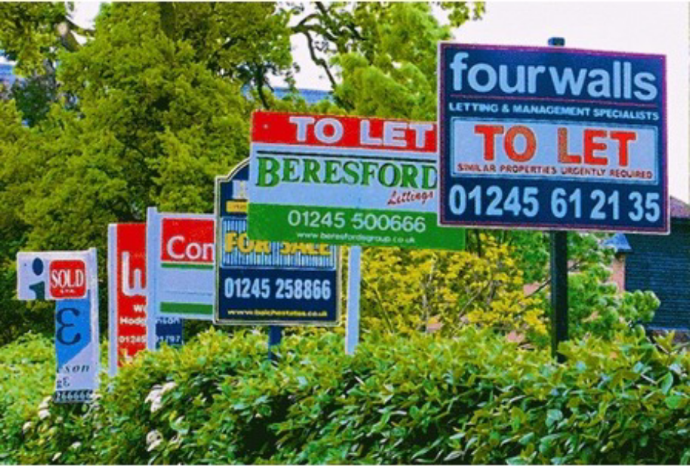
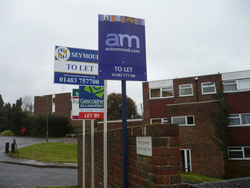
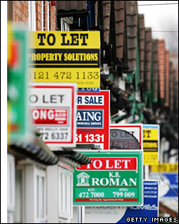

Planning Services – Development Management

Voluntary Code of Practice on Letting Boards in Areas with High Proportions of Shared Housing

Autumn 2016

The Voluntary Code of Practice

Due to the continued concern raised for some time by members of the Durham City local community and resident groups, the Voluntary Code of Practice remains in operation.

The purpose of the Code being to attempt to reduce the number of residential letting boards on display in areas with high proportions of shared housing within the Durham City area. Since the Code was initially introduced in 2011, there has been a reduction in the number of boards displayed but there remains the view that the number of boards is excessive and some boards are often displayed longer than necessary and are used as general advertising for the agent, even though the particular property may have been let.

As part of the County Council’s commitment to protecting and enhancing environments throughout the County, such matters have been dealt with by officers but the opinion remains that further action is required. Whilst these options are being considered, including the request for a Regulation 7 to be submitted to the Secretary of State, the Code continues in Durham City.

The Voluntary Code was introduced after consultations in Autumn 2010, with local resident groups, the local Member of Parliament and the local property and letting agents known to be active in the area, the County Council introduced a Voluntary Code of Conduct. It came into force for a trial period between November 2011 and March 2013, and enabled all parties involved in the initial consultation to provide comments on how successful the Code had been, and introduce any amendments to improve where necessary.

The result being a further amended Voluntary Code of practice for Letting Boards within stipulated streets within the Conservation Area of Durham City.

It is proposed that the voluntary code will be in force for a period from 1 October 2016 to 31 March 2017, and every year thereafter unless replaced by Article 7 if approved by Secretary of State.

The Council will continue to reconsider all the results of the scheme to determine the success of the Code. If it is considered that the Code has still not achieved the desired results, the Council will consider taking further formal action to pursue tighter control of the display of letting boards through the introduction of a Direction under Regulation 7 of the Town and Country Planning ( Control Of Advertisement) Regulations).

To enable a more accurate monitoring of the Code all agents will be asked to provide a list to the Local Planning Authority of those properties they intend to advertise in the year before October and then an updated list in January the following year of those properties that have been let to tenants (lists to be sent to pamela.glaister@durham.gov.uk).

Scope of the Voluntary Code

The key issues covered by the Code are:
- Number of boards displayed by an individual company in a concentrated area
- Length of time boards are displayed
- Size and shape of boards
- location of boards
- Area to be covered by the Code

Measures included in the Code effective from 1 October 2016

In order to ensure compliance with the Code advertisers will need to ensure they abide by the following standards:

1) Number of Boards

Code Requirements:

That letting agents are restricted to one board per individual property type per agent per street with a maximum of 1 board in any one street from any one agent/landlord, with the exception of Hallgarth Street and Gilesgate where two boards can be displayed with a distance of no less than 20 properties.

2) Length of time boards are displayed

Code Requirements:

That no To Let boards are displayed before 1st October in any one year and all boards are removed before 1st April the following year.

3) Size and shape of boards

Code Requirements:

The size of all boards are restricted to the limitations of the Town and Country Planning (Control of Advertisements) (England) Regulations 2007 .i.e. 0.5 sq (approx 70 cm by 70 cm) for a single board or 0.6 sq m (approx 78 cm by 78 cm) for two joined boards.

4) Location of boards in relation to building, garden, etc

Code Requirements:

Boards must be attached to buildings and be no more than 3.6 meters above ground level and should not be placed on posts in the gardens or grounds, with the exception of premises where the distance from outer front door to back edge of pavement is more than 5 metres. In instances where post signs are allowed they should not overhang the highway.

5) Area to be covered by the code

Code Requirements:

That the code applies to the streets within the Conservation Area of the following locations within Durham City,( see attached appendix map of Conservation Area)

Viaduct area to include; Sutton Street, Mowbray Street, Waddington Street, Ainsley Street, Flass Street, Bridge Street, Atherton Street, East Atherton Street, Mitchell Street, Lambton Street, Redhills Lane, Parkside., Tenter Terrace, Highgate
Byland Lodge area to include; Hawthorn Terrace, Laburnum Avenue, Lawson Terrace, Mistletoe Street, Holly Street, John Street, Alexandria Terrace, May Street and The Avenue.
Crossgate area to include; Allergate, Crossgate, Neville Street, Summerville, Palatine View, Nevilledale Terrace, Briarville. , St Margarets Court
Gilesgate area to include; Ravensworth Terrace, The Chains, Kepier Terrace, Gilesgate, Kepier Villas, Mayorswell Street, Mayorswell Field, Renny Street, Ellis Leazes, Douglas Villas, Magdalene Heights, Station Lane, The Sidings, West View, Magdalene Street., Wynyard Grove, Young Street,
Central area to include; Claypath, Providence Row, Finney Terrace, Wanless Terrace and The Sands. Elvet Waterside, Church Street, Hallgarth Street, Mavin Street, Church Lane, Whinney Hill, Mountjoy Crescent, Back Mountjoy, The Hallgarth, Boyd Street, Gladstone Villas, Highwood View, Highwood Terrace, Anchorage Terrace, Un ion Place, Old Elvet
Further Information

Further information on the code and how to comply with its requirements can be obtained from any of the following Officers:

Sarah Eldridge, Team Leader Central and East Team
(t) 03000 263968 (e) sarah.eldridge@durham.gov.uk

Pam Glaister, Senior Enforcement Officer, Central & East Team
(t) 03000 263966 (e) Pamela.glaister@durham.gov.uk

